## Chapter 2

## Literature Survey

2.1 Blood Donation app ‘National Blood Banks Directory’ was developed in the year 2016 for the purpose of donating and receiving the blood. This app contains state/city wise list of Blood banks. This app is useful for particular area not universally. In fig. 2.1.1. Telephone is not mentioned for contact.

It is very important for donor to know basic details about the receiver and also to contact with the receiver the contact number is required. So the contact no plays important role in Blood bank System. In fig. 2.1.2. Telephone is mentioned for contact.[7]

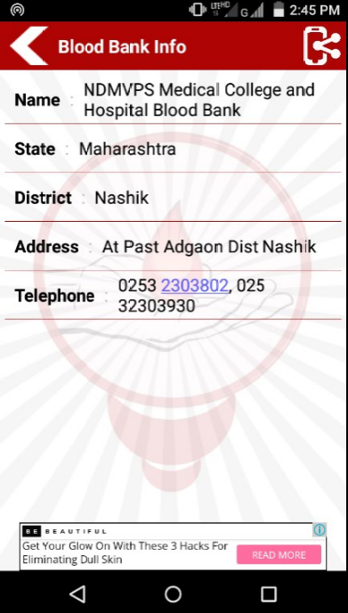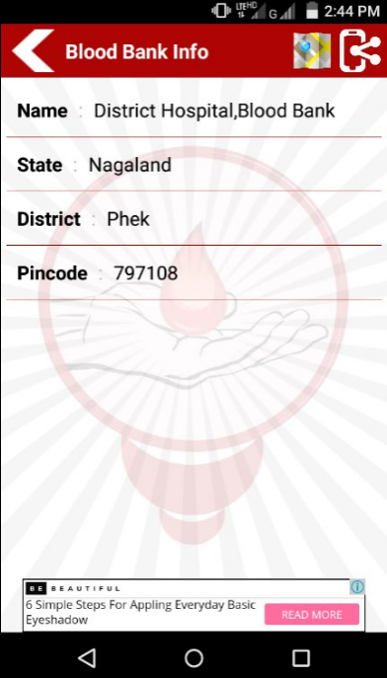

Fig.2.1: Screenshot of Blood Banks India Fig.2.2: Screenshot of Blood Banks India

Directory for Nagaland State Directory for Maharashtra State